3D Printing Slicing Software

1. Software installation

Creality 3D slicing software is a simple 3D slicing software and it is a host computer software developed based on the company's products. By inputting STL, obj and other format files to generate the processing files required by the 3D printer . When we use this slicing software to open an STL file, we can perform a series of operations such as viewing the model, moving, scaling, and rotating in the 3D view. The model is imported into the software. By completing the preparation of the model and related parameter settings and other preparations, the software will automatically perform slice calculation on the model. After the slice is completed, the file will be transferred to the 3D printer and printing can be performed. Note that the slice file name cannot be Chinese or special characters when it is saved as a GCode (save slice) code.

1. Installation step

After clicking on the installer, the page pops up. Click Next to complete the installation. The installation location is free to choose.

Automatically install the driver

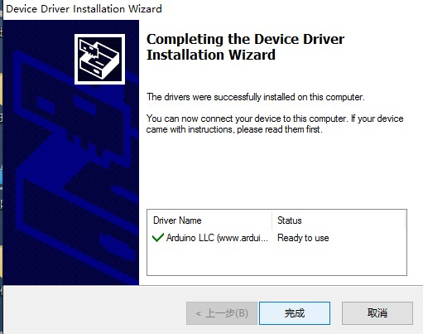

2.To open the software for the first time, you need to set the language and machine model, as shown below.

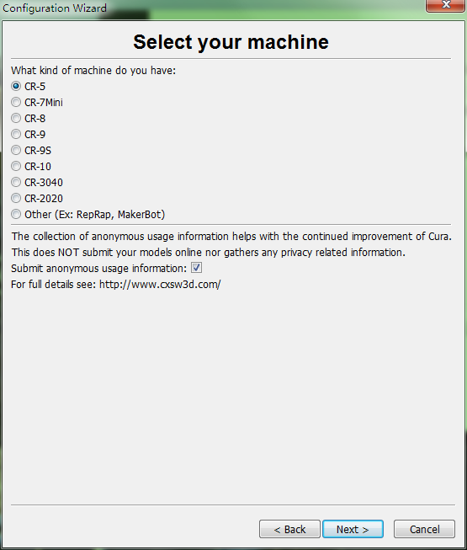

After selecting the machine model, there will be corresponding reference parameters, eliminating the need to set the parameters.

1. introduction of software

Since software can only import STL, obj, AMF, JPG and other formats, 3D modeling is required before 3D printing. Commonly used three-dimensional software includes SolidWorks, Pro\E, UG, 3D Max, and so on, and a three-dimensional scanner can also be used to acquire three-dimensional data of an object and generate a three-dimensional model in a digital manner. The model can also be downloaded online. But the model downloaded from the Internet may be problematic, and later it needs to be repaired by software to repair it (Not necessarily completely repaired). The following is a typical industrial 3D modeling software SolidWorks as an example to introduce how to generate STL files.  
step 1: Enter three-dimensional modeling, taking a simple cube as an example, shown as followed:

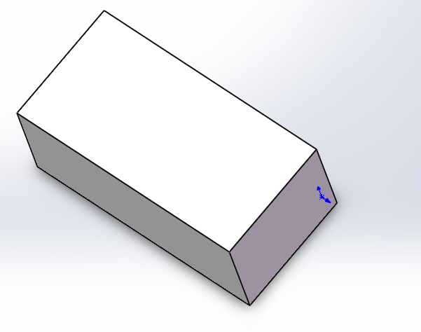

Step 2: Save as "STL" file by clicking "Save As" under the "Save" button, or "Save As" under "File". Select "STL" as the save type and adjust in the "Options" The accuracy of the model after saving,

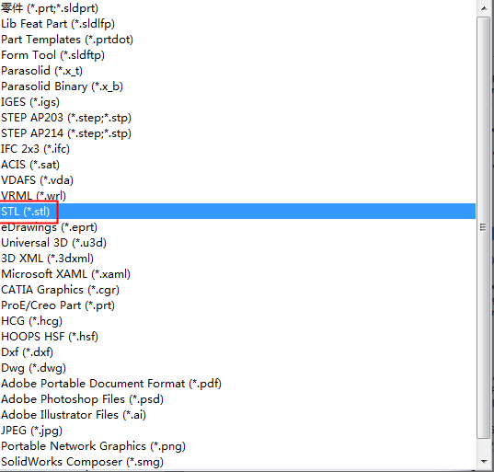

Choose the file format

Now, the well-designed model has been converted into a STL file that can be recognized by the 3D printing and slicing software, and is imported into the slicing software for slicing. After the data is transmitted to the printer, it can be printed.

Next, the specific operation and instructions of the slicing software are formally introduced. This software can realize both offline printing and online printing. Offline printing means use SD card printing, no need to connect the computer to the machine, easy to use, simple operation, it is recommended that users use offline printing. To print online, you need to connect the computer to the 3D printer through the data cable. During the printing process, you cannot power off the computer. The computer cannot screen save or sleep to prevents data transmission failure and is relatively tedious to use. Users are generally not advised to use it.

1. Import STL file  
   Open the slicing software, click on the "Open the model" option in the "File" menu, find the STL file you want to print, select "Open", the software interface will appear the design of the model, as shown. When the imported model is displayed in gray, indicating that the model exceeds the print range, the model size or placement must be adjusted; if it is displayed in yellow, it is normal.

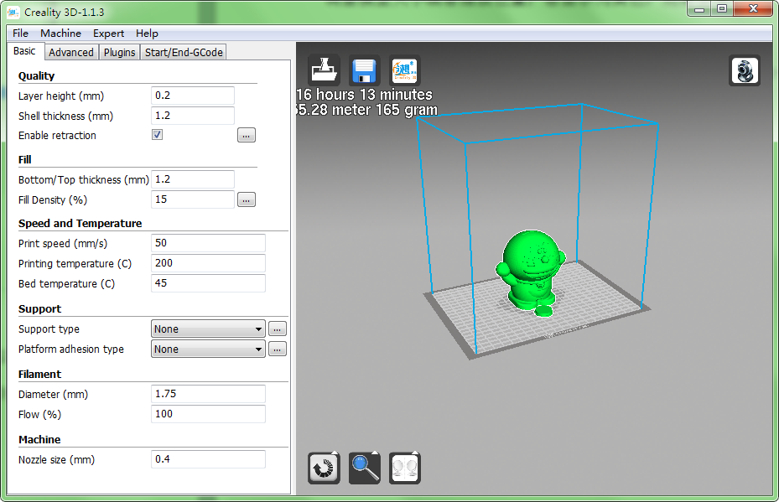

1. "Parameter Settings" under the "File" option in the upper left corner can modify the language and some basic settings as shown in the figure below.
2. 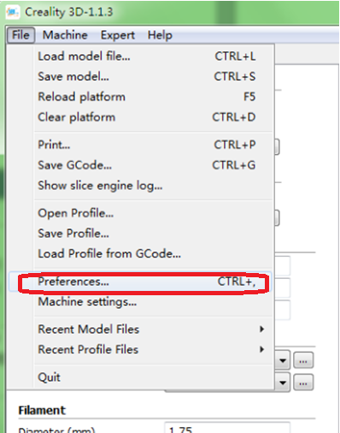

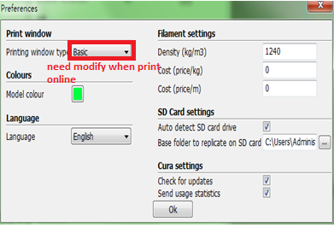

1. **Introduction to offline printing**

Offline printing uses SD card printing, no computer connection, easy to use, simple operation, it is recommended that users use offline printing. After the import model has set the relevant parameters, when the software calculation is completed, the window will display the time required for printing and the amount of consumables consumed. The actual print time of the complex model will be different from the calculated time.

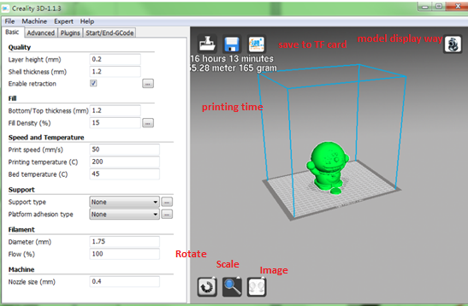

Select model, click the right of mouse

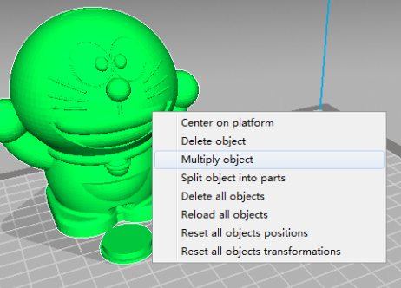

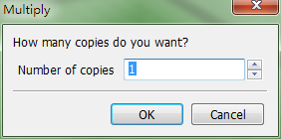

By "File" > Save "gcode" file, the name must be English or numeric, can not be named into Chinese or special characters, save the sliced file to the SD card, and then insert the card slot, turn on the power, the print step is displayed Select "print from SD" or "From memory card" in the main menu of the screen, and select the "*.gcode" file just saved. Confirm that warming up is started and printing is performed.

Open the "Parameter Settings"

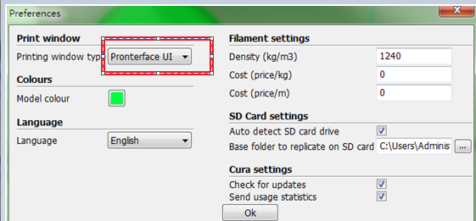

The type of the print window is as shown in the figure above. Click "OK" and click the "Machine type" 》》"Model Settings" menu to open the dialog box as below.

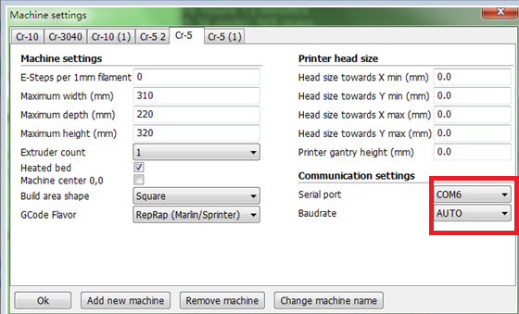

Select the corresponding serial port (different computer serial ports may be different, generally choose the larger one), the Baudrate is "AUTO" or "115200", click "OK".

三、software specifications  
The parameters that need to be modified in the software are mainly the "Basic" and "Advanced" interfaces. The following is a brief introduction.  
1. Basic interface  
  (1) Quality - directly affects the accuracy of printing, the specific options are as follows:

1) layer thickness

Because Fused Deposition Modeling (FDM) prints layers of consumables in a molten state. The height of the layer is the height of each layer of the print model, and the optional height of the layer height is 0.1-0.4mm. The fine print model can usually choose 0.1mm, but the time may be longer; the print quality requirement is not very high, and the model is relatively large, you can choose 0.2mm or more.

2）Wall thickness  
     The wall thickness refers to the edge thickness of the model in the horizontal direction, that is, the thickness of the outermost layer of the section. This parameter determines the number and thickness of edge traces. The number here is generally a multiple of the nozzle diameter.

3）Rollback  
     Rollback is also called the retraction option. When the model crosses a blank area, if this function is not enabled, due to the effect of gravity, the nozzle will flow out of the consumables when moving across the blank area, resulting in wire drawing. Therefore, when this function is turned on to cross a blank area, the extrusion mechanism will retract the material according to the settings and according to the set speed and length.

(2) Fill  
1) Bottom/top layer thickness  
The thickness of the bottom layer and the top layer depend on this parameter . The layer thickness and this parameter are used to calculate the number of solid layers to be printed. According to the layer height of each layer, it is generally set to a multiple of layer height, which is the basis for filling the layer after the bottom layer is printed. If you set a bit thicker, the effect will be much more beautiful, and you will barely see the fill in it, but it will take more time.

2) filling density  
Internal fill ratio, this parameter does not affect the appearance of the model, it is generally used to adjust the strength of the model. If you need a hollow object, just set it to 0; if you need a solid object, set it to 100. Usually the setting range is between 15-30.

(3) Speed/temperature

The printing speed and the nozzle temperature are usually not changed so much. mainly the speed and temperature settings of some printing usually, it can be said to be a global parameter settings. The printing speed is set according to the complexity of the model and the printing effect to be achieved; the nozzle temperature is set according to the optimum printing temperature of the consumables, and the consumables of different manufacturers have different optimum printing temperatures.

(4) Support  
      1) Support type  
     This function sets up some models that need to print support or Raft on the bottom of the model. The support type option is selected by means of the down option. There are three options: none, partial support, full support. General settings select "Partial support." The model is complex, More empty position can be selected "All support", This function will affect the surface effect of the model. The automatically added support is based on the critical angle you set.  
partial support: The support of the bottom of the model, that is the resulting support is only on the platform.  
All support: All the bottoms of the model are supported. Relative to the complex structure of the model is usually chosen to support all, but the effect of the surface will have an effect, you can rotate the model properly, try to choose a support print less suitable position.

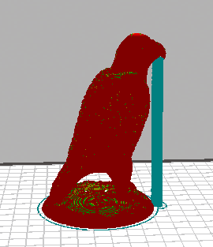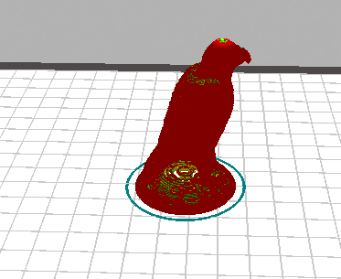

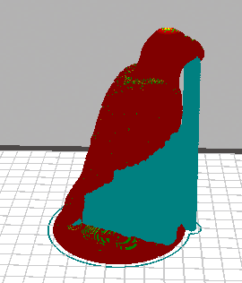None Partial support

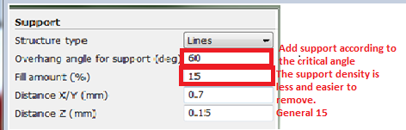

All support

2) Platform attachment type  
      This function is to allow the model to better adhere to the platform, adding an edge or a pedestal. Pull down three options: none, bottom edge, bottom grid.  
      Bottom Edge: Print a few turns of the coil on the edge of the model before printing the model, and then start printing the model. The number of turns of the edge can be set, usually 5-10 turns.

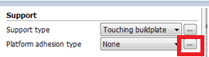

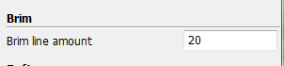

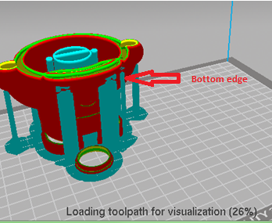

Underlying Grid: The bottom layer prints the grid, and then starts printing the model on the grid to make the model adhere firmly.

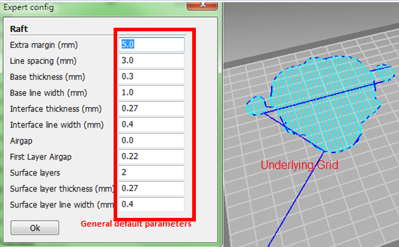

(5) Printing materials and machines  
      Diameter: The diameter of consumables, generally "1.75" and "3.0"; extrusion volume is generally 100% by default. These two factors affect the amount of nozzle discharge, please confirm the accuracy of the consumable diameter.  
      Nozzle aperture: Set according to the aperture of the machine installed nozzle.

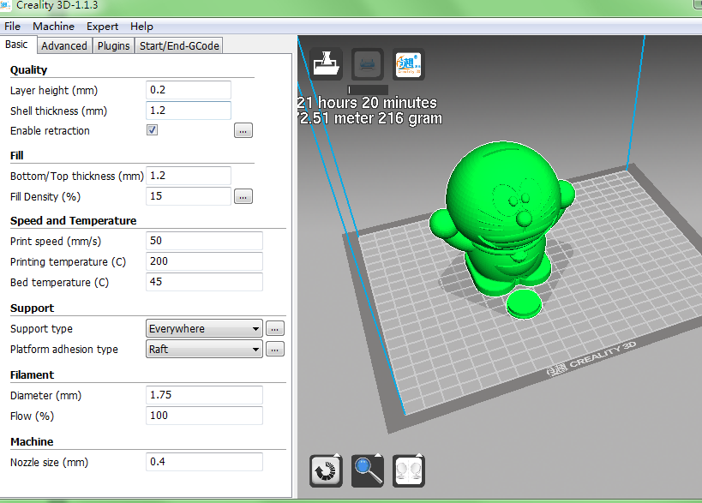

2. Advanced interface

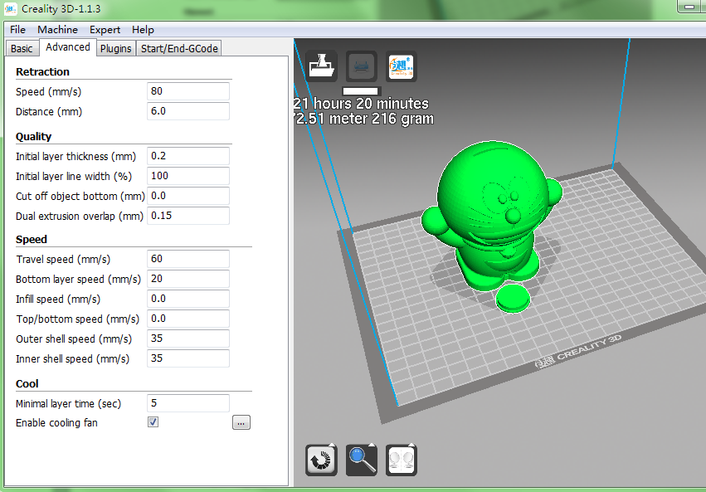

1) Retraction

Retreat speed refers to the speed of the extruder's retreat when the retraction is started. Setting higher speeds can achieve better results, but excessive speeds can cause wire wear. The length of return refers to the length of the returned consumables. The proper setting of the retraction will prevent the wire from appearing in the model.

2) Quality

     Initial layer thickness, print the thickness of the first layer, the general default can be. The initial layer width setting is 100% will be more dense. Undercut refers to the removal of a model that sinks below the platform. Extrude twice by default.

3) Speed

Moving speed: The speed of moving in the non-printing state is recommended to be too high, otherwise it will cause the motor to lose synchronization, generally 60-80.

Underlying speed: Prints the speed of the bottom layer. This value is usually set to be very low, so that the bottom layer and the platform can adhere better.

Infill Speed: The speed at which the fill is printed. When set to 0, the print speed is used as the fill speed. Telling print fills can save a lot of time, but it may have a certain impact on print quality.

Shell speed: The speed of the model shell is printed, affecting the effect of the model surface. The general setting is 30-40mm/s.

Top/bottom speed and inner wall speed are generally set to 0. The default is the print speed.

4) Cooling

Default settings for fan cooling of the nozzles and models.

3. Plug-in interface, it is recommended not to use.

Pause at height, pause printing at a certain height, press the command to continue printing.

Tweak at Z, automatically changes print temperature, print speed, and other parameters at a certain height and continues printing.

4. Expert settings

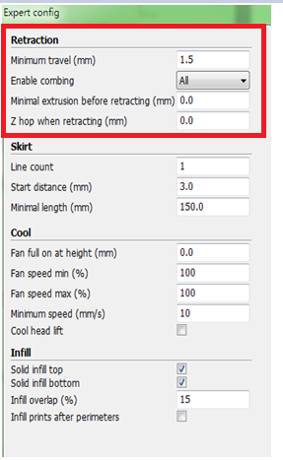

Expert settings include parameters such as retraction, skirt, cool, and Infill.

1) Retraction

Minimum moving distance: The minimum moving distance before a new back-off occurs, avoiding frequent back-off in a small area and affecting the printing effect.

Enable withdrawal: In order to prevent the drawing process from holes happening in the drawing process, if you select “All”, the printer head will move from the start to the end, it will always recover; if you select “External”, it will only be on the outer surface of the model and enable withdrawal; if you select “Internal”, all other prints are withdrawal except for the outer surface of the model.

Minimum extrusion volume before withdrawal: The minimum extrusion length before a new extrusion. It can avoid the digging of consumables caused by frequent withdrawals.

When the Z-axis is lifted when retracting: When the retraction is completed, the print head will rise a certain height. This function is useful for printing tower models.

2) Skirt

Skirt is usually designed to prevent the extrusion head from being in an unfilled state before printing, and is only available when the "adhesion platform type" is "none". But if your model size reaches the limit of the machine's print size, it is best to set it to 0, otherwise it is possible that the extra skirt will exceed the print range.

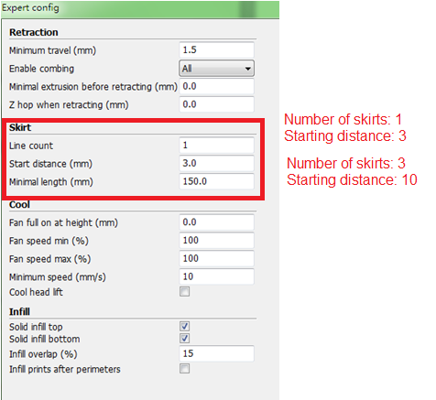

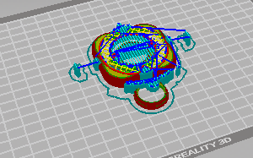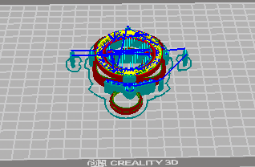

3) Cooling settings

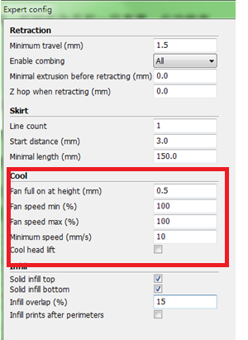

The fan is turned on at full speed: By starting printing, fan cooling does not turn on, allowing the underlying model to better adhere to the platform.

Maximum fan speed and minimum fan speed: If the two are not equal, the slicing software will select a suitable fan speed between maximum and minimum when printing each layer.

Minimum speed: The minimum speed used for each layer of printing. The default is 10.0mm/s. Generally 10.0mm/s is the best. Do not change.

  The nozzle removes and cools: When each layer of least cooling can not meet the cooling, each layer will automatically lift the nozzle to cool, and then print the next layer. It is not turned on by default, generally it is not turned on, and the printing time is extended.

4）Infill

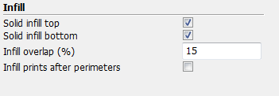

Select to fill the Top/Bottom layer will prints a solid top/bottom layer. If it is not selceted, it prints according to the set fill density.

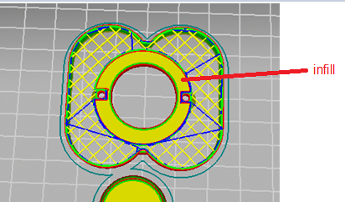

5) Support

For some settings of the support, refer to the support instructions in the previous basic interface.

6) Spiral

      Spiral Printing: This is a function to help print smooth in the Z direction. It will increase Z steadily throughout the printing process. This feature allows the printed object to have a solid bottom.

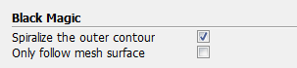

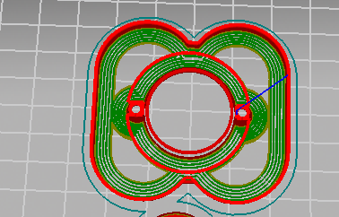

Printing shell: Only spiral printing on the surface of the model, no filling, no top and bottom.

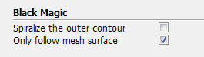

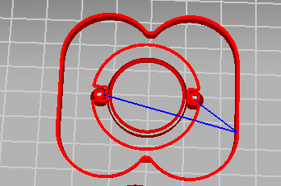

7) Bottom edge (refer to Brim in the previous attached platform type)

8) Underlying Grid (adhering Raft settings in the platform)

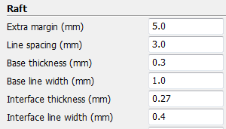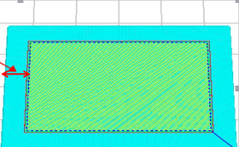

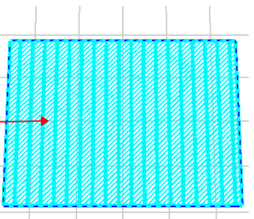2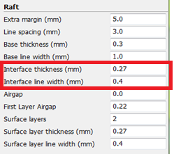

The above parameters are modified according to their own actual conditions. Generally only external lines, line spacing, and surface layers are modified. The rest are default.

9) Fix horrible

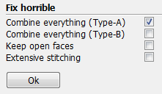

These parameters are only used to modify unclosed voids on the model, generally using the default values. This feature is not valid for the problematic model, it is simply a repair function.